CMPM Selected experimental inference results：

- slow_down/G/W/H/L/IMG_5559.jpg
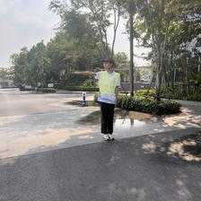
Captions: In a real road traffic intersection environment, with the officer appearing as a small full figure in the center. From my left, I observe a traffic police officer signaling to slow down (The officer indicates that vehicles should slow down by raising the right arm straight upward, palm facing down, giving a clear gesture to reduce speed); he is wearing a green vest, a white shirt, and is wearing a hat.
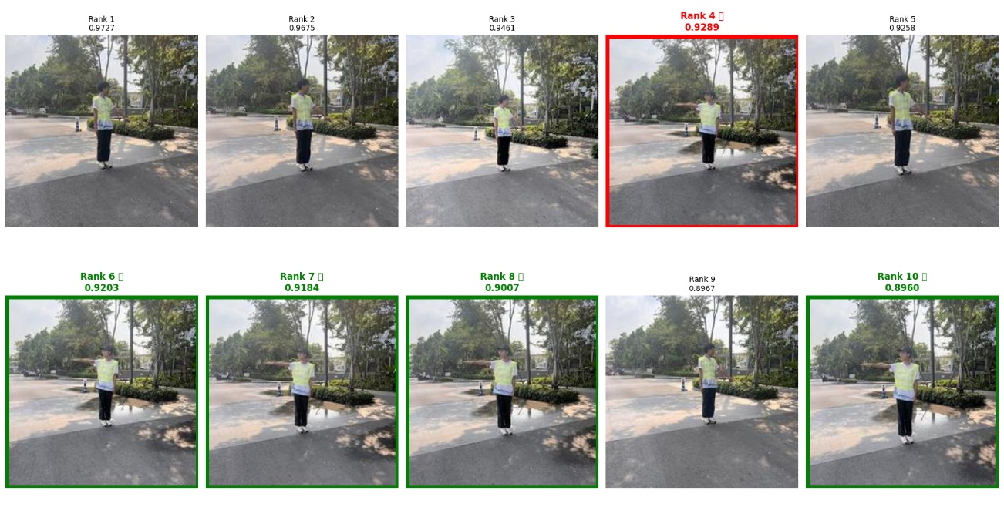
- turn_right/R/B/H/R/IMG_E3489.JPG
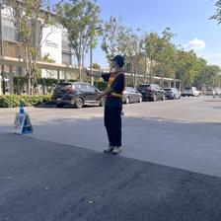
Captions: In a real road traffic intersection environment, with the officer appearing as a small full figure in the center. From my right, I observe a traffic police officer signaling to turn right (For a right turn, the officer extends the right arm straight out to the right side with the palm facing right, raises the left arm upward at an angle, and looks right toward the direction of the turn); he is wearing a red vest, a black shirt, and is wearing a hat.
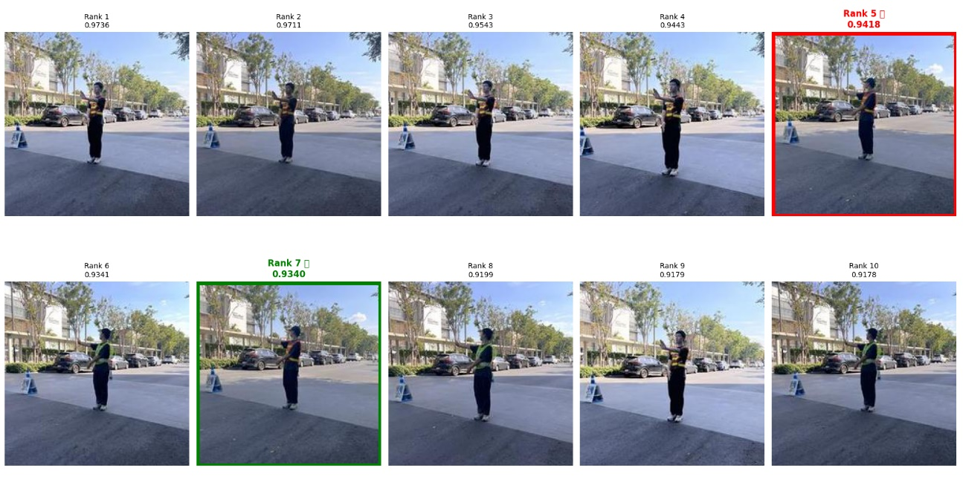
- go_straight/G/B/H/L/IMG_E3853.JPG
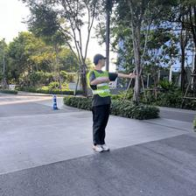
Captions: In a real road traffic intersection environment, with a smaller full-length view of the officer. There, on my left, a traffic police officer wearing a green vest and a black shirt, wearing a hat, is signaling to go straight (To signal vehicles to go straight, the officer stretches both arms out horizontally to the sides, keeping them parallel to the ground and palms facing forward, and turns the head to look left).
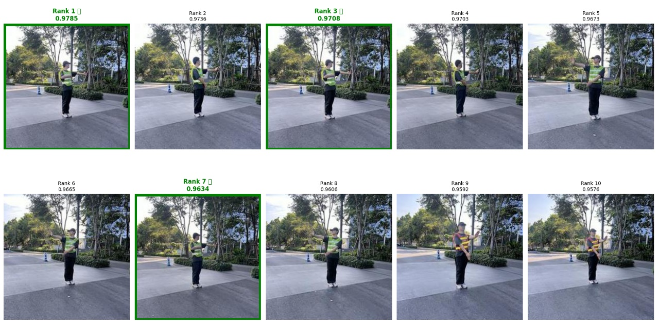
- change_lane/R/W/H/R/IMG_4886.jpg
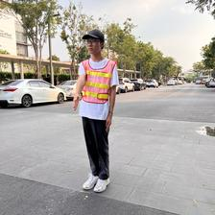
Captions: In a real road traffic intersection environment, with the full-length officer appearing closely. On my right stands a traffic police officer, wearing a hat, signaling to change lane (The officer signals a lane change by raising the right arm diagonally to the side, palm facing inward toward the body, while looking straight ahead to guide the driver into the adjacent lane) and dressed in a red vest with a white shirt underneath.



